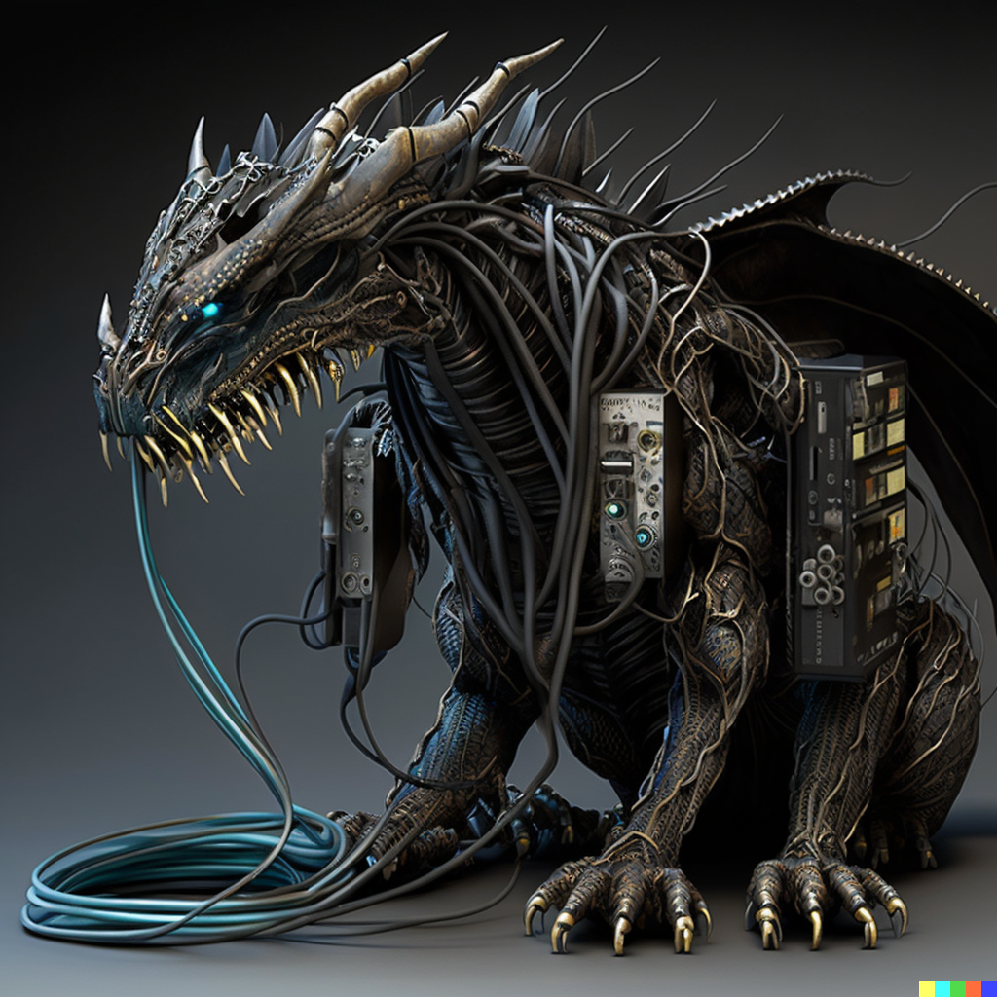

**An Image of Ouroboros**

**Genres**  
  
  
  
Action RPG